

MCA Semester – III

Applied Learning Project Report

|  |  |
| --- | --- |
| **Name** | **Abhimanyu Surendran** |
| **USN** | **241VMTR01327** |

**Applied Learning Project**

**Master of Computer Applications**

*Submitted by:*

**Abhimanyu Surendran**



**Table of Contents**

|  |  |
| --- | --- |
| **Title** | **Page Nos.** |
| Introduction | 4 |
| Features Implemented | 6 |
| Technologies Used | 8 |
| Live Deployment Details | 9 |
| Results and Evaluation | 11 |
| Conclusion | 12 |

# 1. Introduction

Campus Club is a responsive multi-page website developed to present campus-related activities, student events, club initiatives, and communication details in a structured and visually appealing format. The website functions as an informational hub where students can explore upcoming programs, view images from previous events, learn about the club’s objectives, and contact organizers for participation or collaboration. All content is accessible without authentication, making the system open and easy to use for all students.  
  
The main goal of this project is to apply frontend development concepts learned during the course and convert them into a real working website. By using HTML for structure, CSS for styling and animations, and JavaScript for interaction and dynamic behavior, the project demonstrates how modern websites provide smooth user experiences without server-side processing.  
  
Many institutions still rely on scattered communication channels such as notice boards, messaging apps, and social media posts. Campus Club addresses this problem by offering a centralized platform where all event-related information is presented consistently. This reduces confusion, improves participation, and helps students stay updated with campus activities more effectively.

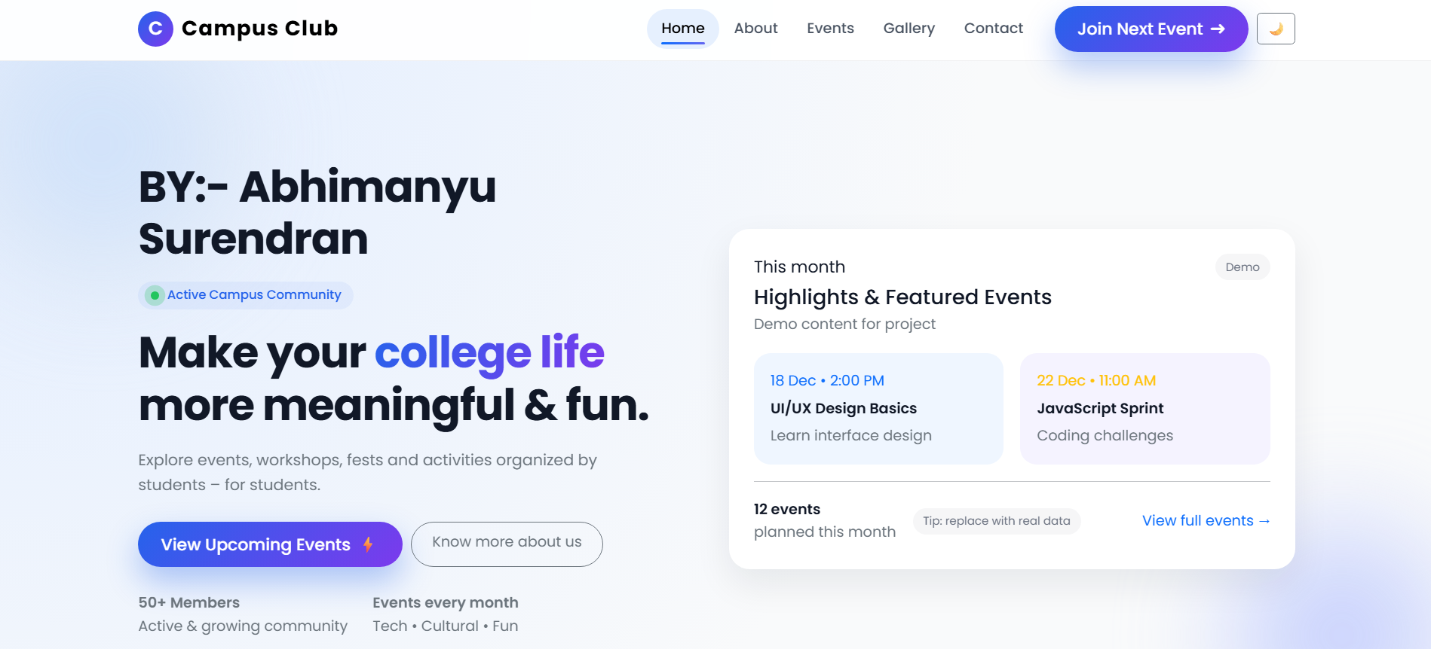

Figure: Home Page – Hero Section and Navigation

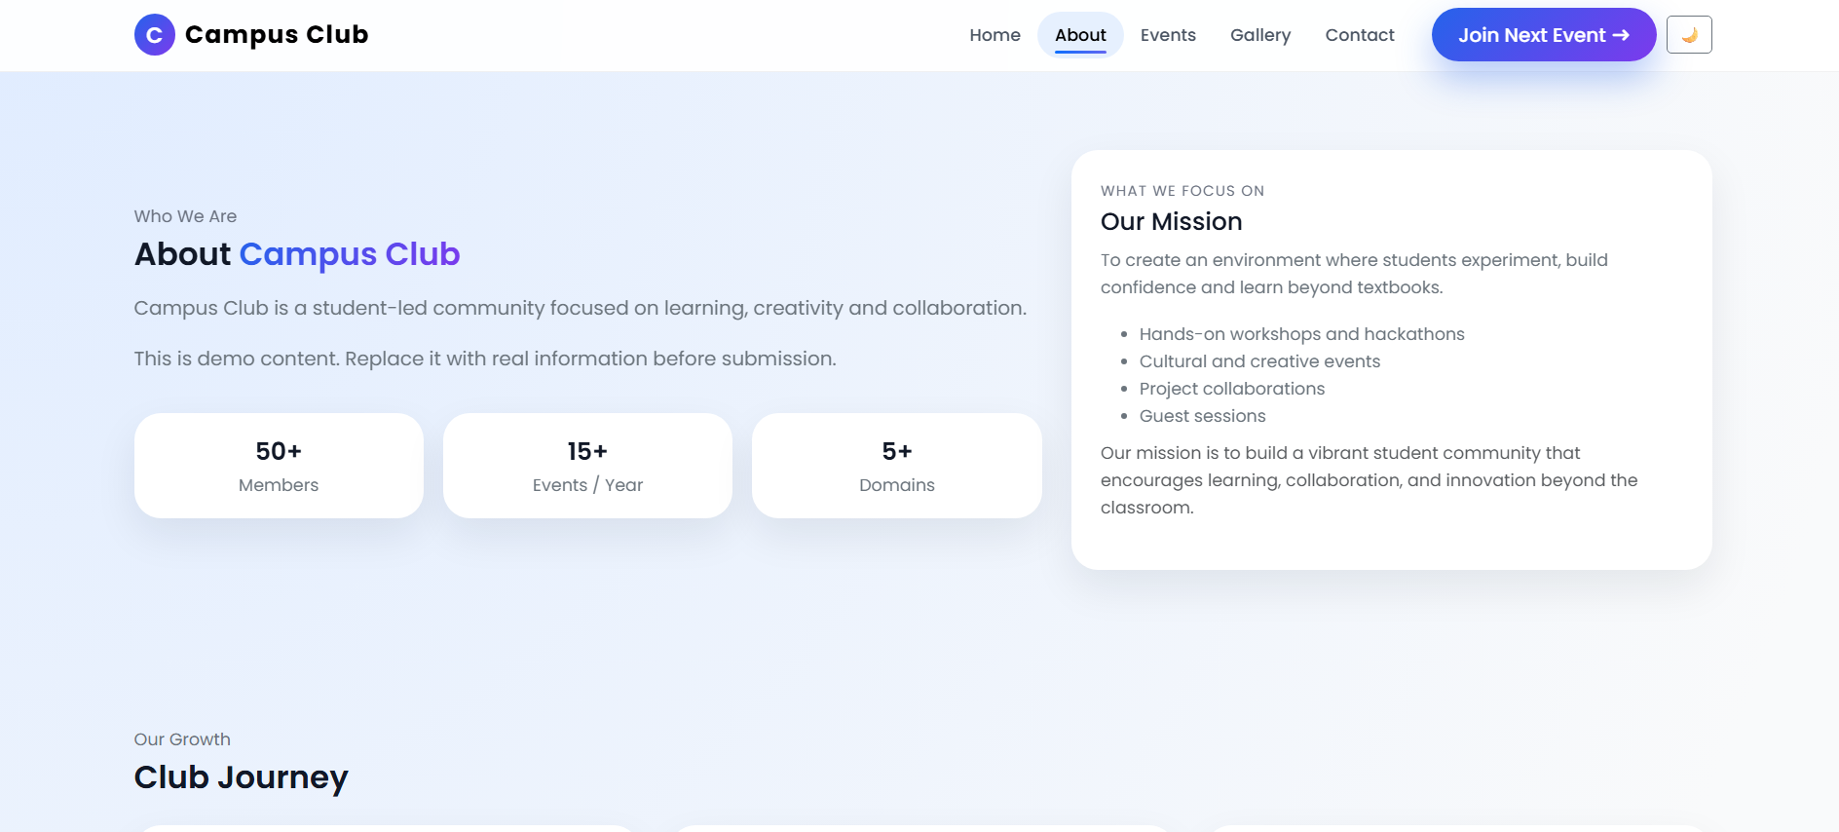

Figure: Home Page – Statistics and Highlights Section

# 2. Features Implemented

The Campus Club website includes several fully working features that enhance both appearance and usability. These features are divided into user interface features and functional interactive features implemented using JavaScript.  
  
User Interface Features include responsive navigation bar, modern card layouts, gradient buttons, fade-in animations, hover effects on images and buttons, floating label input fields in forms, and consistent typography across pages. These elements improve readability and provide visual feedback when users interact with the website.  
  
Functional JavaScript Features include dark mode toggle with theme persistence using localStorage, scroll-to-top button with smooth scrolling behavior, animated statistical counters, real-time event search, category-based filtering of events and gallery images, lightbox modal for full-screen image viewing, event save option stored in localStorage, and demo alert-based feedback for registration and load more actions.  
  
Each HTML page has its own JavaScript file that controls its behavior. This modular approach ensures clean separation of concerns, easier debugging, and better scalability of the project structure.

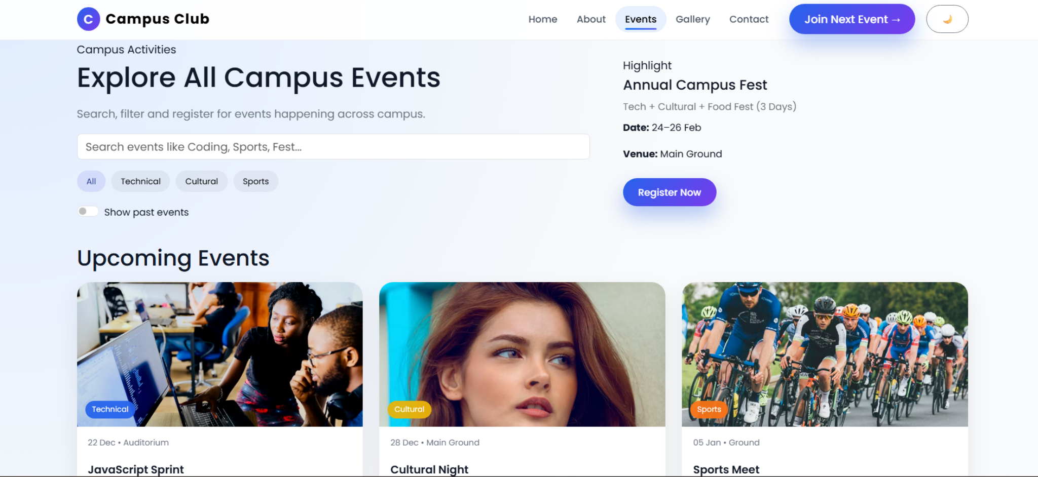

Figure: Events Page – Search and Category Filters

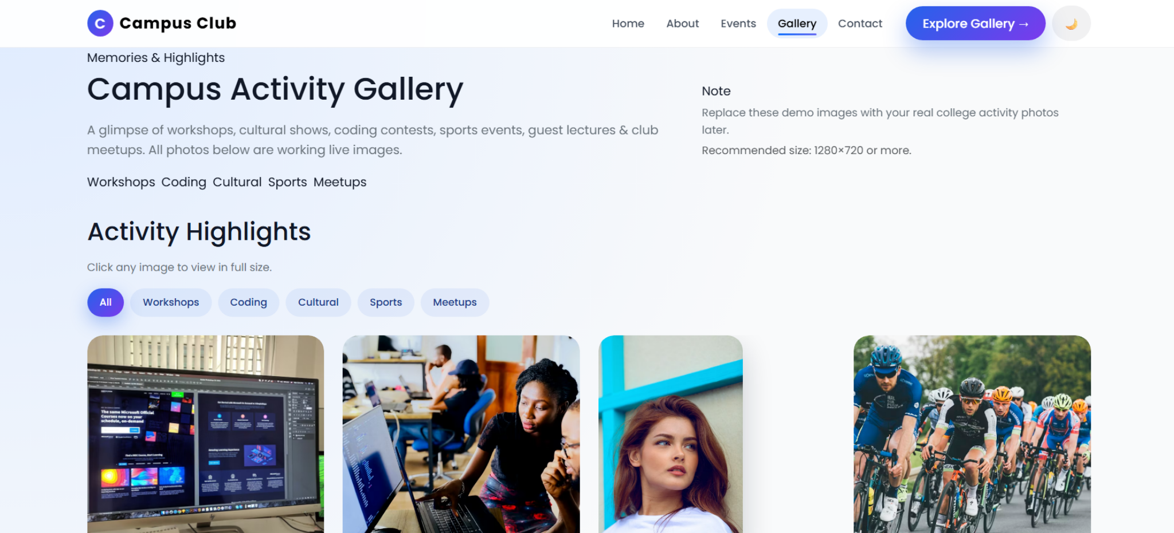

Figure: Events Cards with Tags and Register Option

# 3. Technologies Used

The Campus Club project is developed using widely adopted web technologies that are suitable for building responsive and interactive frontend applications.  
  
HTML5 is used to define the structure of the website including navigation bars, content sections, forms, and image galleries. Semantic HTML tags improve readability and accessibility.  
  
CSS3 is used extensively for layout design, animations, dark mode styling, gradient backgrounds, hover transitions, responsive behavior, and visual enhancements. Media queries and Bootstrap grid system ensure the website adapts to different screen sizes.  
  
JavaScript is responsible for handling all interactive behavior including event listeners, DOM updates, localStorage access, filtering logic, and animations triggered on scroll. Vanilla JavaScript is used without external JS frameworks.  
  
Bootstrap 5 is used for layout grid, spacing utilities, modal structure, and responsive components. Google Fonts provides consistent typography. Git and GitHub are used for version control and deployment using GitHub Pages.

# 4. Live Deployment Details

The Campus Club project is deployed as a static website using GitHub Pages. GitHub Pages is a free hosting service that allows developers to publish HTML, CSS, and JavaScript files directly from a GitHub repository.  
  
Live Website Link:  
https://abhimanyusurendran.github.io/campus-club-project  
  
Deployment Process:  
First, all project files were pushed to a GitHub repository. Then GitHub Pages was enabled from the repository settings by selecting the main branch as the deployment source. GitHub automatically builds and hosts the website at a public URL.  
  
Since this is a frontend-only demo project, no login credentials are required for evaluation. All features are accessible to anyone who opens the link in a browser.

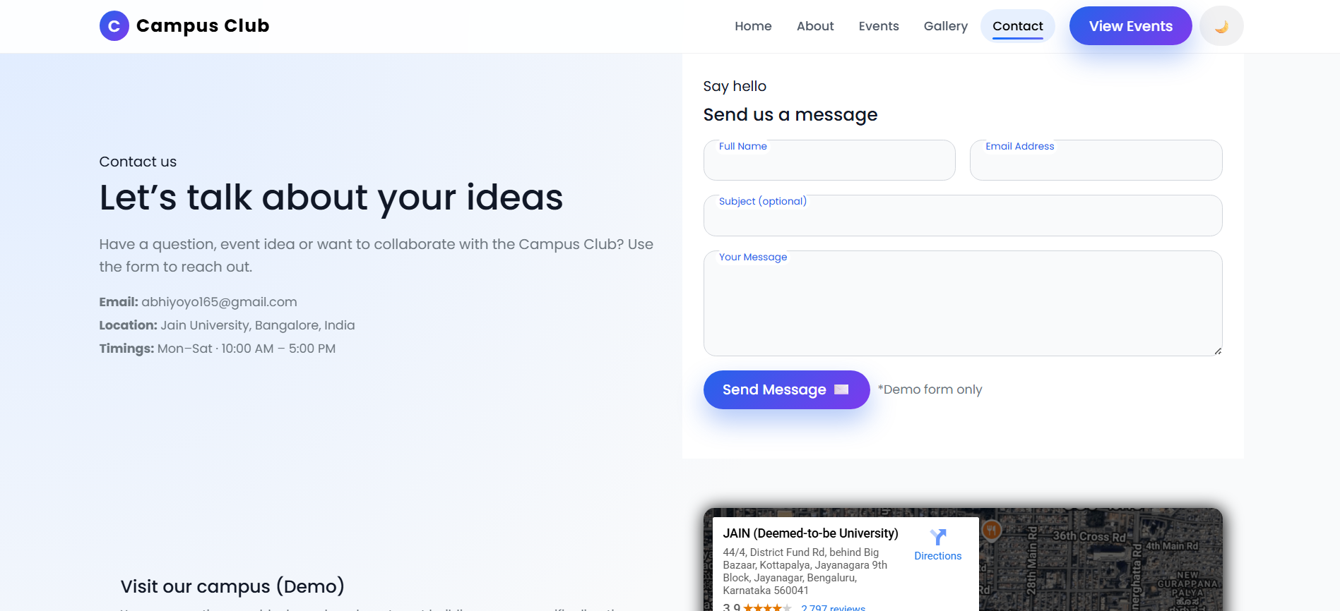

Figure: Gallery Page – Category Filtering of Images

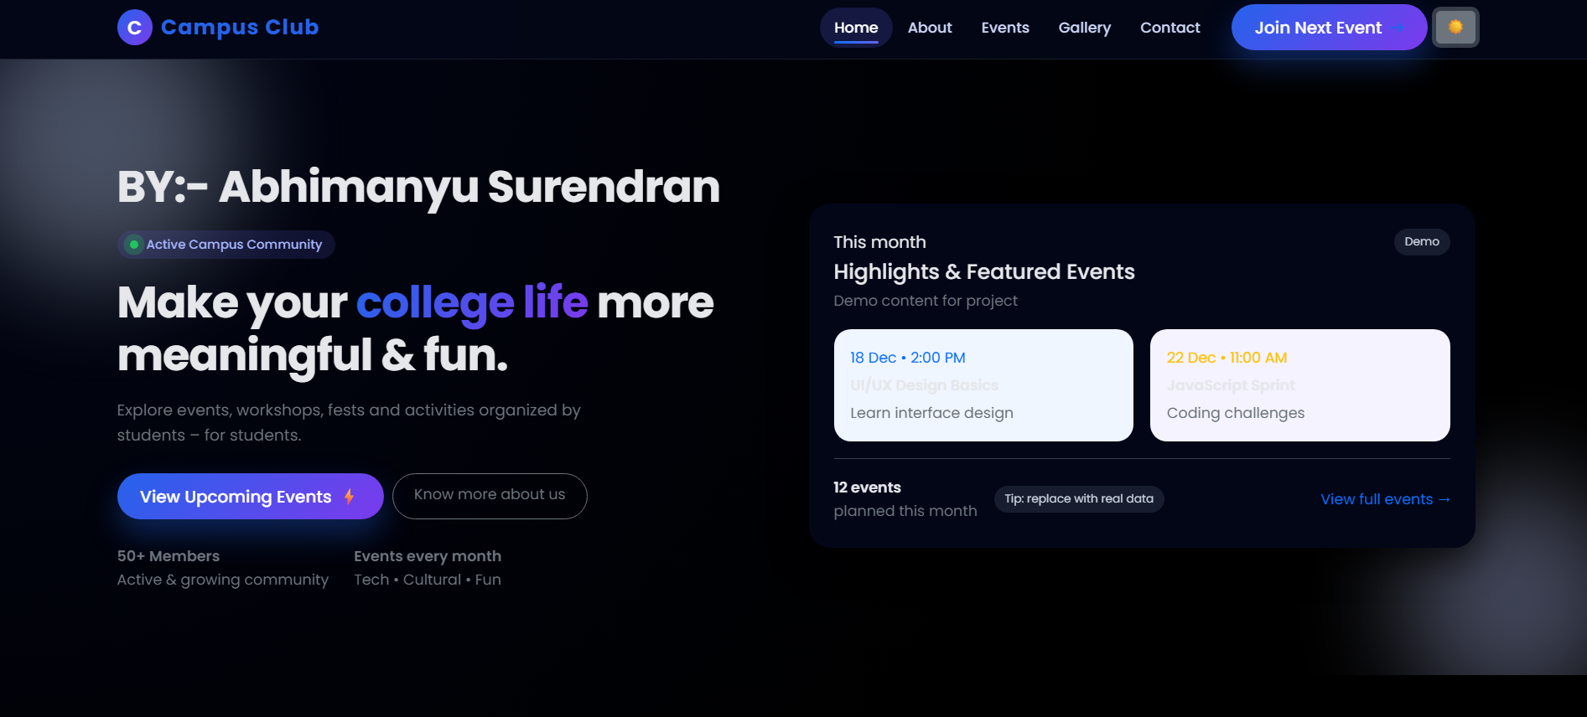

Figure: Contact Page – Form and Map Section

# 5. Results and Evaluation

The final version of the Campus Club website successfully fulfills all the functional and design requirements defined at the beginning of development. All interactive features were tested manually to ensure correct behavior and smooth transitions.  
  
Event search and category filters work in real time and instantly update visible event cards. Dark mode toggle saves user preference and restores it when the page is refreshed. Gallery image modal opens and closes correctly using both close button and keyboard escape key. Animated counters and fade-in effects trigger at the appropriate time during scrolling.  
  
Responsive testing confirms that layouts adjust correctly on mobile, tablet, and desktop screen sizes. Navigation menus, buttons, forms, and cards remain usable across resolutions.  
  
According to the evaluation rubric, the project satisfies all criteria including proper HTML-CSS-JS linking, multiple working interactions, enhanced animations, successful live deployment, organized file structure, and professional UI presentation.

# 6. Conclusion

The Campus Club project provided valuable hands-on experience in building interactive and responsive web applications using only frontend technologies. It strengthened understanding of DOM manipulation, event-driven programming, layout design, and deployment processes.  
  
Key skills gained include writing modular JavaScript, managing UI state using localStorage, designing reusable CSS components, and implementing user-friendly interactions such as filters, modals, animations, and smooth scrolling.  
  
Completing this project improved confidence in building real-world websites and prepared a strong foundation for future full-stack development projects. The project meets all Applied Learning objectives and demonstrates practical application of classroom concepts.